**CogniAble YourStory**

**[Tech30] How Gurugram-based CogniAble is using ML for early detection of autism spectrum disorder**

[yourstory.com](https://yourstory.com/2020/10/tech30-gurugram-startup-cogniable-machine-learning-autism?utm_pageloadtype=scroll)

Shreya Ganguly

8-9 minutes

**Autism spectrum disorder** isn’t easy to understand, but depictions in TV and movies have helped familiarise us with the **developmental disorder that affects communication and behaviour**.

Till now, lack of awareness and medical information often led several people to suffer quietly from illnesses such as depression, bi-polar disorder, autism spectrum disorder, Asperger’s syndrome, and others.

Things are changing now.

With the spotlight trained on mental health, several **entrepreneurs, innovators, and startups** are doing **their bit to ensure proper treatment and a better quality of life** for people suffering from such disorders.

Gurugram-based **CogniAble is using machine learning-based assistive technology to ensure early detection and affordable treatment of autism spectrum disorder**.

Get connected to CogniAble

Founded in 2016 by Manu Kohli with his wife Dr Swati Kohli, Dr Prathosh AP and Dr Joshua Pritchard, the startup aims to bring **affordability, accessibility and high-quality management** to homes across India.

Autism can be diagnosed at any age, but it is said to be a “developmental disorder” as symptoms generally appear in the first two years of life. This is why CogniAble is focusing on early detection byproviding an **online platform where people can upload videos of children and get them screened for autism.**

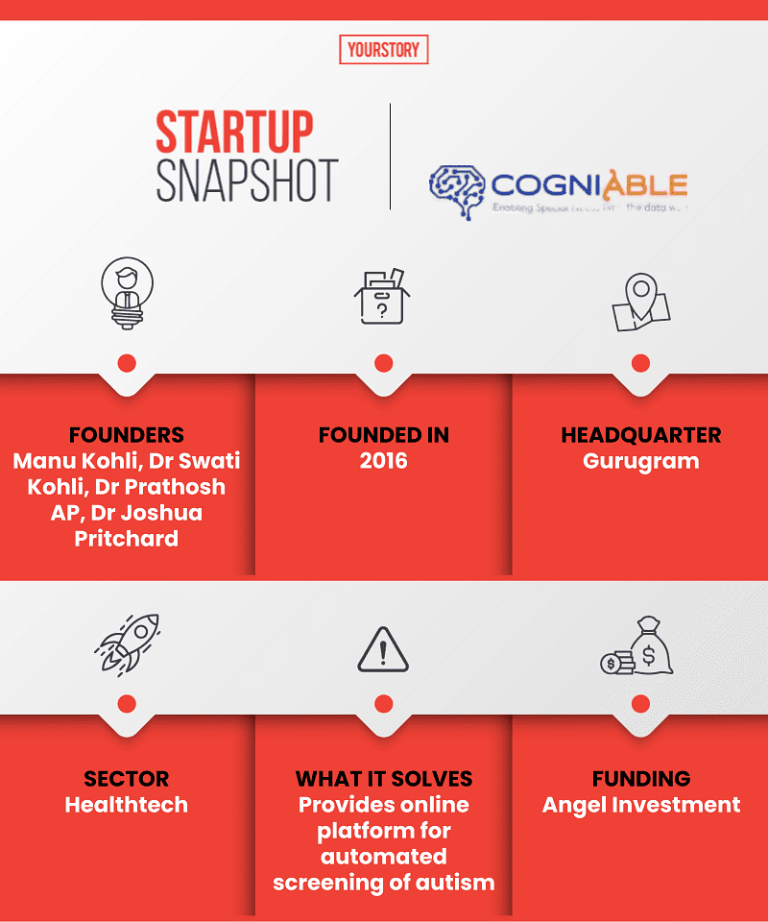

*Illustration: YS Design*

Get connected to CogniAble

**The early journey**

Speaking to ***YourStory***, Co-founder and CEO Manu Kohli says he was always interested in technological solutions.

“Married to a child psychologist and a special educator, I have seen the growing demand of special needs services in India. However, **the major transformation came after our son was diagnosed with autism**. While exploring services in India, the US, and Europe, and by experiencing autism services as a parent, we saw an opportunity and understood **the need of technology to manage both: autism screening and intervention**,” Manu says.

The co-founder says he and his wife had **four main objectives**: affordable service, ability to be used by non-experts, a remote solution, and a data-driven platform.

Manu, an engineer and management graduate has 16 years of experience, and is working on his PhD at IIT-Delhi, focusing on developing affordable and scalable solutions for neuro-developmental disorders. Dr Swati has **18 years of experience in working with children with neuro-developmental delays**.

They were joined by their friends, IIT-Delhi faculty member **Dr Prathosh,** an expert in computer vision who holds a PhD degree from IISc Bangalore, and **Dr Joshua**, who holds a PhD in behaviour analysis from the University of Nevada and runs his own autism clinics in the US.

**Using technology to solve problems**

Quoting data from **Indian Academy of Pediatrics**, Manu says **all children should be screened using standardised autism screening tools** between 18 and 24 months of age. However, limited health professionals and infrastructure mean several children are diagnosed a year or two late.

“CogniAble is an online platform available remotely for early screening and affordable behavioural intervention for autism spectrum disorders,” he says.

It provides two solutions: **early automated screening** for autism and **digital therapy management.**

The co-founder explains that users can upload videos of children using the mobile application. These are analysed by **deep learning models to identify fine motor, gross motor, and complex actions** based on a stimulus provided by a caregiver.

The proprietary algorithms conduct an analysis and give an **autism screening prediction** by providing a **risk score**. The prediction is made on the basis of 12 behavioural landmarks suggested by doctors.

“We have developed **innovative transfer learning techniques using computer vision**; two patents have been filed. The innovation allows us to develop **machine learning models with 25 percent of the video data**.”

After detection of autism, **behavioural therapies are key to develop necessary skills** promoting school and societal inclusion of children. The platform enables parents, schools, and institutes to get **access to integrated assessment and treatment plans at 20 percent of the traditional costs**, the founder claims.

“Even in metro cities, **behavioural treatment services cost more than Rs 3 lakh a year, an amount that is unaffordable for the majority**. India has more than 15 million individuals with autism, and we are adding 200,000 new cases every year,” the CEO explains.

CogniAble is available on both **Android** and **IoS**. It offers **personalized intervention plan** in 21 domains such as **language, behaviour, academics, classroom, and social skills**. These are available in the form of **lesson plans and video modelling** with data recording and feedback provisions.

“Our machine learning models build **customised treatment for the child**, measuring **longitudinal treatment progress** with structured and unstructured data. This brings significant change in the self-dependency and skills of children at a young age,” he says.

Apart from the co-founders, CogniAble has a **12-member team**, including seven psychologists, four technical experts, and a business development and marketing manager. **Twelve subcontractors** work with the startup in the areas of psychology and mobile & app development.

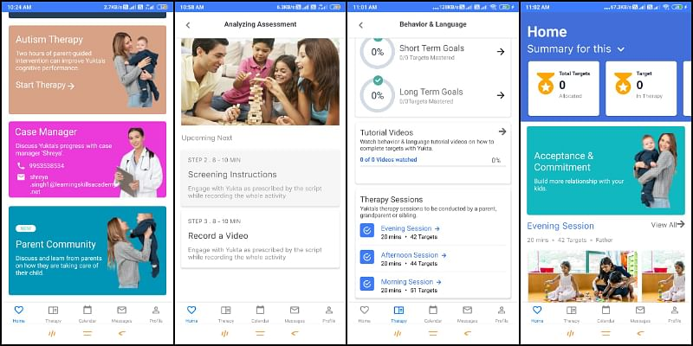

*CogniAble's online platform, which is available remotely, helps in early screening and affordable behavioural intervention for children with autism spectrum disorders. [Image Credit: CogniAble]*

**Business and more**

The co-founders launched the company with **an initial investment of Rs 50 lakh**. Manu says the company has raised seed funding and also received grants and awards.

“We are **looking for funds to enhance technology features, make machine learning models mature, and scale and enter markets** in India, the US, and other countries,” he says.

The co-founder also added that the company works with **Dr. Monica Juneja,** professor at Maulana Azad Medical College and **Dr. Manushree Garg** from Vardhman Mahavir Medical College Delhi **for further development and clinical trials of the products**.

The founder explains that the startup operates on three business models - it works with **governments** through primary and secondary healthcare centres and public hospitals, **B2B** with special need clinics, schools, private hospitals, and the **B2C model,** where it works directly with parents.

“For B2G and B2B segments, **our solution is available as a mobile app for a monthly subscription cost** ranging between Rs 600-800 per month per learner. For B2C customers, our price is around Rs 3,500 as it includes four personalised sessions with experts for **assessment , programme creation, revision, and explanation**,” Manu says.

Six clinics from India, the US, and Bangladesh are at present using the application with more than 100 users. The startup has also joined hands with **Fortis Mental Health** to scale up its presence in the Asia-Pacific region.

Like CogniAble, **Chennai-based** [**Nimaya Robotics**](https://yourstory.com/2020/03/chennai-startup-nimaya-robotics-autism-special-education) is also involved in helping autistic children learn to perform basic functions and lead an independent life. It uses robotics-based therapy.

CogniAble plans to develop its mobile application to **support multiple languages** and ensure maximum reach. It is also looking to **integrate acceptance and commitment therapy into the application** for parents or therapists working with special needs children.

“In the long term, we plan to offer **diagnostic and prescriptive solutions for behavioural health disorders** such as ADHD, dementia, Alzheimer’s, and learning disability.

“**Our biggest goal is to work with the government** and convince them to **integrate CogniAble screening services with normal vaccination schedules** in the age group of 2-5 years. We also want to **reach community workers in India**, train them, and take our services to Tier II and III towns and villages,” Manu says.